MINOR PROJECT

NAME: AYAN PANJA

CLASS: BME-III

SEC: A

ROLL: 001811201007

*SIMULATION OF THE SHAPE OF LEIDENFROST DROPLET*

Introduction:

The term Leidenfrost droplet comes from the effect named Leidenfrost effect. The effect is named after the German doctor ‘Johann Gottlob Leidenfrost’ who described it in the year 1751.

When liquid is boiled inside a hot container at a certain temperature much higher than the boiling point a vapor layer is generated between the hot surface and liquid droplet which acts as insulator and keeps the liquid from boiling. These droplets are self-propelling in nature hence are very desiriable in industrial fields as no additional power is required for propagation. A heat engine based on this effect has been prototyped.

Theory:

In 1934 professor S.Nukiyama initially done his work on boiling. It was observed that the boiling is not uniform with respect to the excess temperature()i.e. the difference between wall temperature and saturation temperature of the liquid. He observed four different boiling regimes:natural convection boiling, nucleate boiling, transition boiling & film boiling, which is illustrated in the following boiling curve.

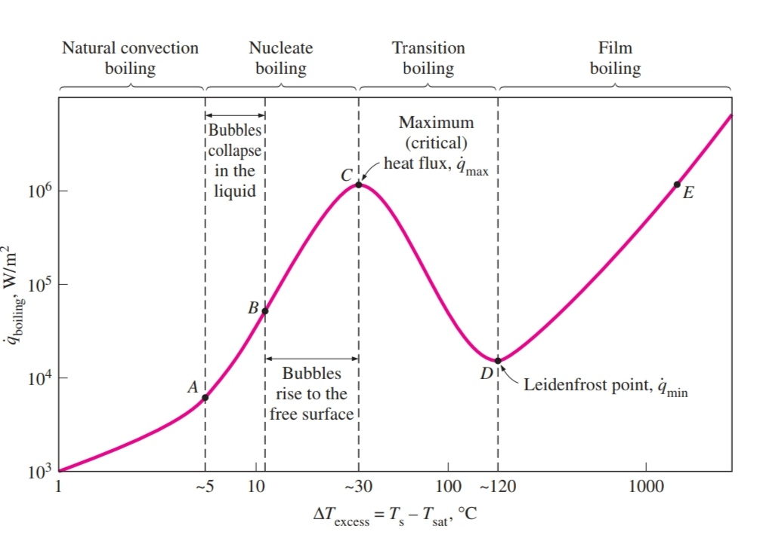

In film boiling region the heater surface is completely covered by a continuous stable vapor film. Point D, where the heat flux reaches a minimum, is called Leidenfrost Point.

The presence of a vapor film between the heater surface and the liquid is responsible for the low heat transfer rate in the film boiling region. The heat transfer rate increases with increasing excess temperature as a result of heat transfer from the heated surface to the liquid through vapor film by radiation, which becomes significant in high temperature.

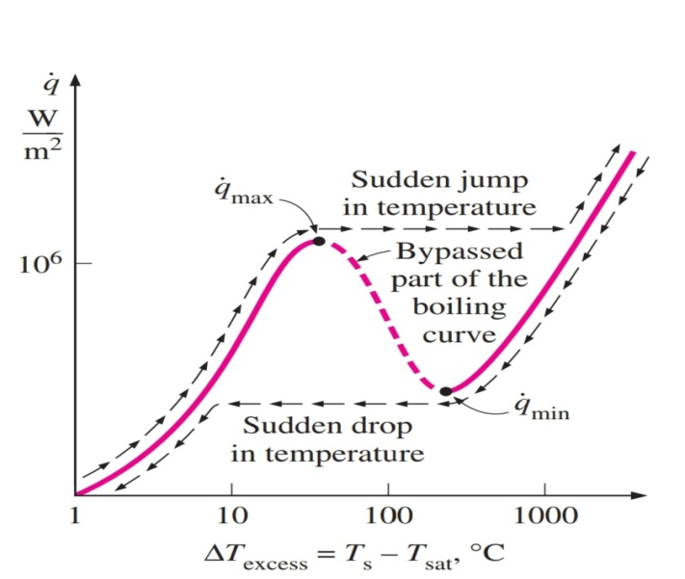

Although in practical case boiling will not follow the boiling curve beyond C; when power is applied in water exceeds burnout occurs in the wire as it suddenly reaches its melting point. Carrying out the experiment with platinum wire, which has a much higher melting point, we can avoid the burnout and can maintain heat fluxes higher than . When we gradually reduce power, we obtain the cooling curve with a sudden drop in excess temperature when Leidenfrost point is reached. Minimum heat flux which occurs at Leidenfrost point was derived by Zuber using stability theory. The corresponding expression for minimum heat flux for a large horizontal plate,

MATHEMATICAL FORMULATION:

Here we’ve tried to find the shape of a sessile droplet deposited on a hot metal surface during spray quenching.

The LFP is achieved from the film boiling region and at the transition state between film and transition boiling.

The assumptions associated with the model:

1. Upper surface of the droplet is exposed to constant ambient pressure.
2. Initial subcooling of the droplet shortly following deposition is ignored.
3. Any internal circulation within the liquid droplet is neglected.
4. Any temperature variation within the droplet during the evaporation process is ignored.
5. The wall is assumed to possess sufficient high thermal mass that its temperature ,, remains unchanged during the evaporation.
6. The vapor layer is very thin compared to the droplet size.

Vapor flow dynamics: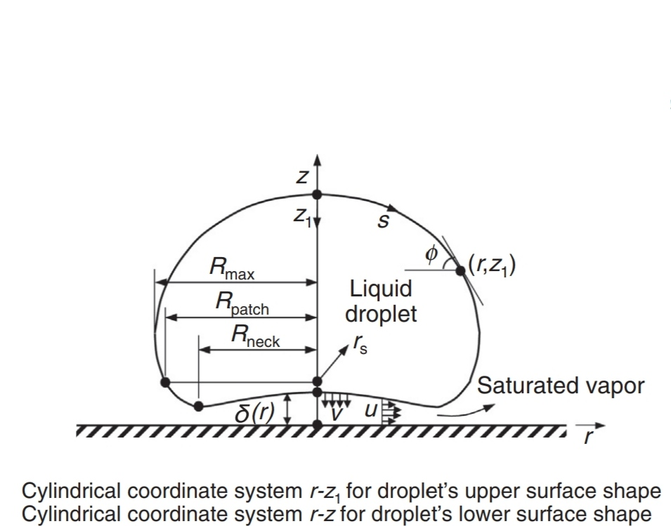

When the surface reaches LFP temperature a thin vapor layer is generated between the droplet and heating surface which prevents the droplet from direct contact with the wall. Due to very small thickness of vapor layer the momentum equation is given by

----(1)

[pg , g, u are local vapor pressure, vapor viscosity and local radial vapor velocity respectively]

Radial velocity at bottom surface is neglected, and at solid surface due to no slip radial velocity is zero. Therefore radial velocity is subjected to the boundary conditions

----(2a)

----(2b)

Integrating (1) with B.C. 2a,2b yields

----(3)

Pressure in vapor layer, -----(4)

Where is the liquid pressure and are liquid density, gravity, surface tension and surface curvature respectively.

Vapor velocity w in z-direction is obtained by continuity equation

------(5)

With the boundary condition w=0 at z=0, (5) can be integrated to yield

----(6)

Which, combined with (4) reduces to the form

---(7)

The vapor production rate per unit area from the lower droplet interface can be obtained from the heat balance

----(8)

, being the latent heat of vaporisation, vapor conductivity, emissivity and Stefan-Boltzman constant respectively.

Mass conservation for z direction vapor velocity w requires that

------(9)

By substituting (8),(9) into (7) and introducing capillary length

------(10)

The following equation is obtained for dimensionless vapor layer thickness:

----(11)

Where parameters with an asterisk are nondimensionalized using capillary length with =, =δ/l, =kl and parameter is a dimensionless parameter accounting for fluid properties and surface heating,

----(12)

Droplet shape analysis:

As illustrated in the above figure the surface of a sessile droplet can be divided into two parts along the perimeter of the circle of radius

Upper droplet surface:

The shape of the upper droplet surface is governed by a balance between hydrostatic pressure and capillary pressure.

----(13)

Where is surface curvature at r=0 and is measured from the droplet apex. By introducing capillary length eq. (13) can be nondimensionalized to the form

---(14)

It is convenient to solve eq. (14) in terms of arc length s along the surface from the droplet apex as shown in the above figure. Introducing angle between tangent of arc and horizontal line eq. (14) can be transformed into

--------(15a)

---------(15b)

-------(15c)

Subjected to the boundary conditions

) = 0 ----(16a)

----(16b)

----(16c)

All the length parameters are nondimensionalized relative to capillary length. The three first order ordinary differential equations can be easily solved by fourth order Runge-Kutta method from the droplet apex to the patching point.

Lower droplet surface:

The curvature for the lower surface of the droplet is approximated as

----(17) [=the nondimensional

vapor layer layer thickness beneath the sessile droplet.]

Introducing the two variables f1 and f2, defined as

-------(18a)

-------(18b)

Eq. (17) and (11) can be rearranged, respectively, into the two following ordinary differential equations,

--------(19)

--------(20)

To ensure a continuous droplet shape the position, slope, curvature should match that of the upper at the patching point and the curve should be continuous. Therefore the boundary conditions for eqs. (17)-(20) are

1. (due to zero slope and curvature from symmetry),
2. At r= and k must match corresponding values obtained from the upper surface solution.

Eqs. (17)-(20) along with the boundary conditions are solved by the Runge-Kutta and shooting methods.

Simulation:

In case of the upper curve there are three simultaneous O.D.E. [eqs (15a),(15b),(15c)] which along with the boundary conditions [eqs (16a),(16b),(16c)] constitutes a typical boundary value problem. It’s solved by fourth order Runge-Kutta method using a matlab code. The submission of code is done at the end of this report.

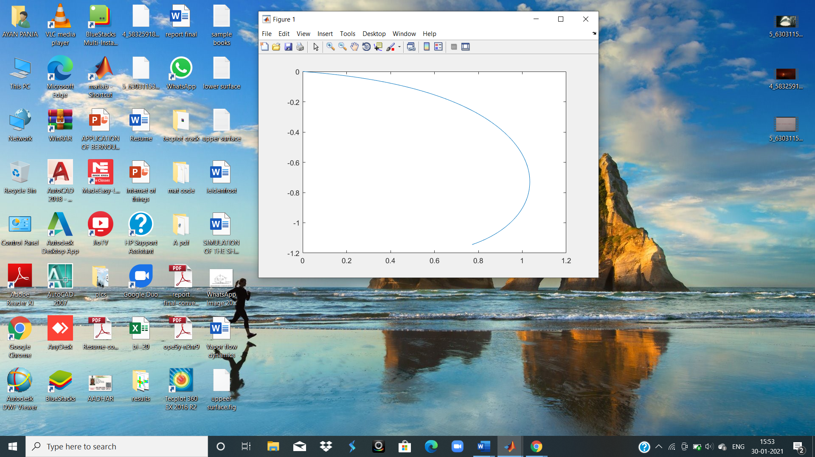

For = 0.2

Submission of code:

clc

clear all

h=0.001; %initializing step size

s=0:h:2; %initializing domain of independent variable s

n=length(s);

q=zeros(1,n); %angle of tangent of arc with horizontal line

r=zeros(1,n); %radius of droplet

z=zeros(1,n); %height of droplet

k=input('enter value of curvature at apex : ');

F=@(z)(z+k);

G=@(q)(cos(q));

H=@(q)(sin(q));

for i=1:n-1 %%implementing RK4 method

j0=F(z(i));

k0=G(q(i));

l0=H(q(i));

j1=F(z(i)+0.5\*l0);

k1=G(q(i)+0.5\*j0);

l1=H(q(i)+0.5\*j0);

j2=F(z(i)+0.5\*l1);

k2=G(q(i)+0.5\*j1);

l2=H(q(i)+0.5\*j1);

j3=F(z(i)+l2);

k3=G(q(i)+j2);

l3=H(q(i)+j2);

s(i+1)=s(i)+h;

q(i+1)=q(i)+(h/6)\*(j0+2\*j1+2\*j2+j3);

r(i+1)=r(i)+(h/6)\*(k0+2\*k1+2\*k2+k3);

z(i+1)=z(i)+(h/6)\*(l0+2\*l1+2\*l2+l3);

end

plot(r,-z)